Ex.No:1: Simulation of FDMA in MATLAB Date:21-7-26

Aim: To simulate a Frequency Division Multiple Access (FDMA) system using MATLAB and analyze its communication performance in terms of channel bandwidth, data rate, and signal-to-noise ratio (SNR).

Objective 1:
To simulate an FDMA system by allocating individual frequency channels to multiple users
and determine the channel bandwidth assigned to each user.Output Parameter: Channel Bandwidth (kHz)

Objective 2:
To calculate the data rate achieved by each user in the FDMA system based on the allocated channel bandwidth.
Output Parameter: Data Rate (kbps)

Objective 3:
To evaluate the communication quality of the FDMA system by calculating the Signal-to-Noise Ratio (SNR) for different users.Output Parameter: Signal-to-Noise Ratio (SNR) (dB) Procedure
- Open MATLAB and create a new script file.
- Define the total available bandwidth, number of FDMA users, carrier frequencies, signal
power, and noise power.
- Allocate a unique frequency channel to each user and calculate the channel bandwidth.
- Compute the data rate for each user based on the allocated bandwidth and modulation
scheme.
- Calculate the Signal-to-Noise Ratio (SNR) using the signal and noise power values.
- Plot the transmitted signals of all FDMA users using different carrier frequencies.
- Display the calculated channel bandwidth, data rate, and SNR in the MATLAB
Command Window.

- Analyze the results to verify independent channel allocation and evaluate the overall
performance of the FDMA System

Program (Matlab Code):
clc; clear; close all; fs=1000; t=0:1/fs:1; TBW=600; Users=3;
CBW=TBW/Users; fc=[100 300 500];
m=sin(2*pi*10*t); s1=m.*cos(2*pi*fc(1)*t); s2=m.*cos(2*pi*fc(2)*t); s3=m.*cos(2*pi*fc(3)*t); subplot(2,1,1) plot(t,s1,'r',t,s2,'g',t,s3,'b'),grid on
title('FDMA Channel Allocation'),xlabel('Time (s)'),ylabel('Amplitude')
subplot(2,1,2) bar(1:Users,CBW*ones(1,Users)),grid on
xlabel('Users'),ylabel('Channel Bandwidth (kHz)'),title('Channel Bandwidth per User')

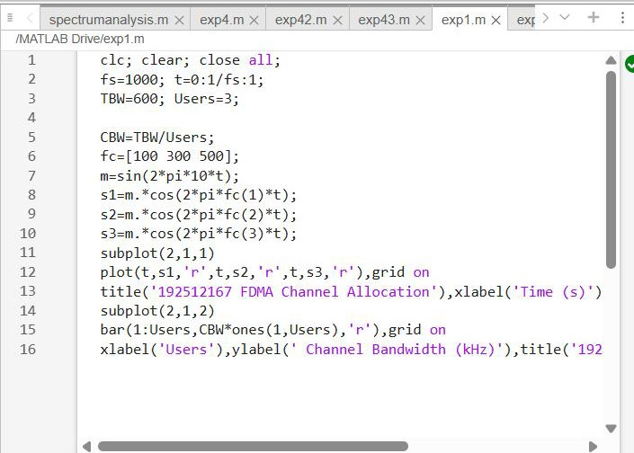
Output: Objective 1:

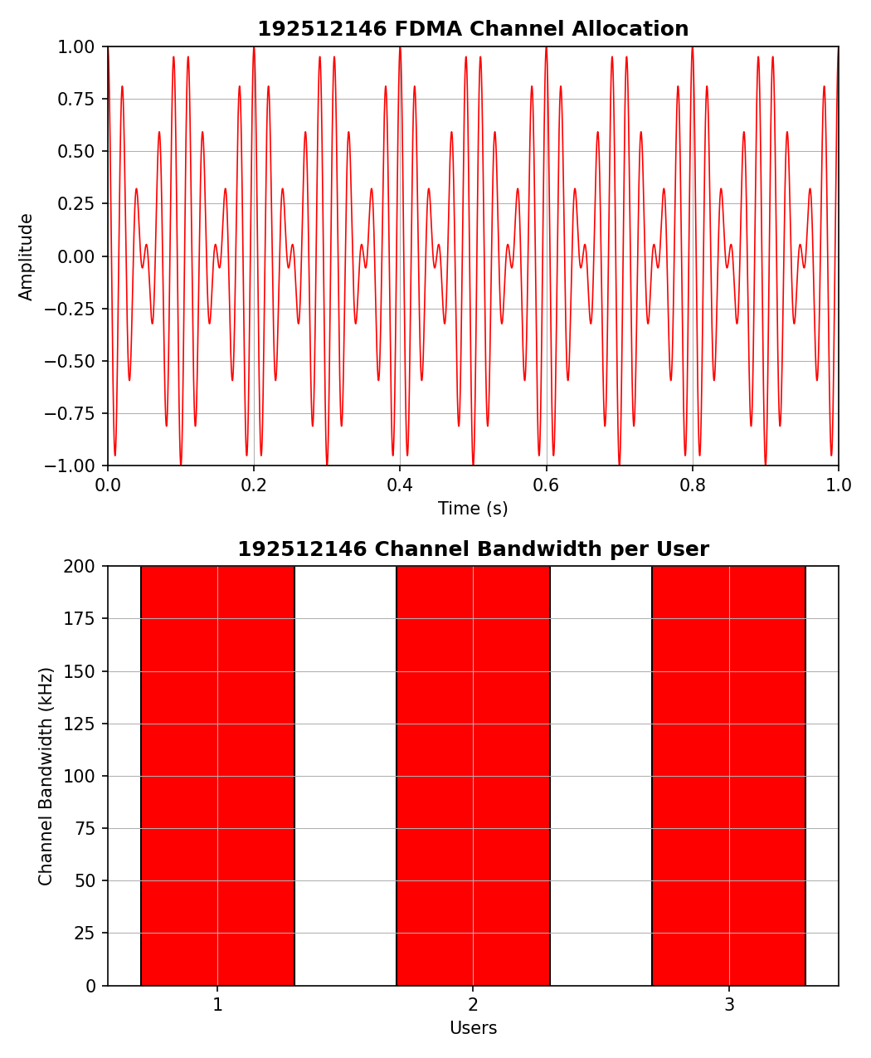

Objective 2: Matlab Code and Output
clc; clear; close all;
BW = 200; % Channel Bandwidth (kHz) Users = 3;
M = 2; % BPSK Modulation
DataRate = BW*log2(M); % Data Rate (kbps) Rate = DataRate*ones(1,Users);
disp(' User Data Rate (kbps)') disp([(1:Users)' Rate']) figure bar(1:Users,Rate) xlabel('Users')
ylabel('Data Rate (kbps)')
title('FDMA Data Rate for Each User') grid on

Output: Objective 2:

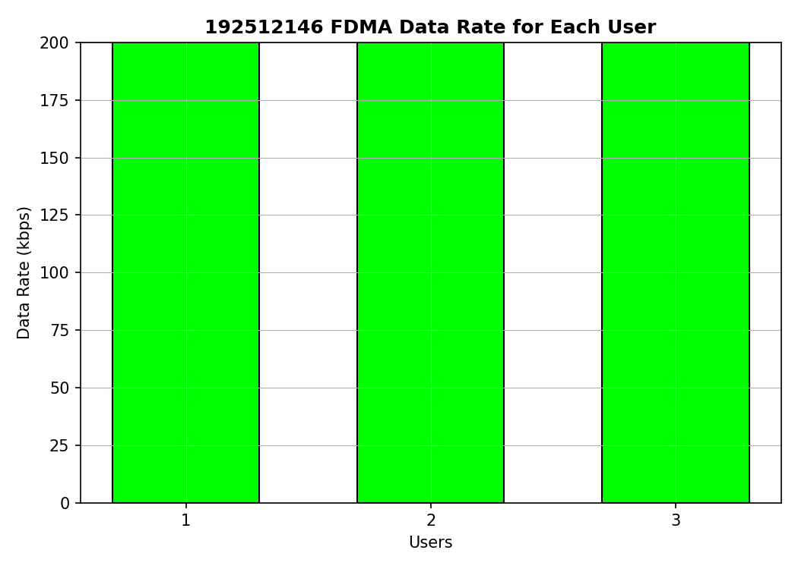

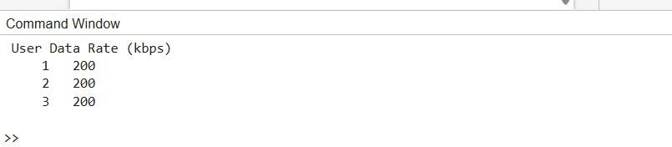
Objective 3: Matlab Code and Ootput clc; clear; close all;
Ps = 1; % Signal Power (W)
Pn = [0.1 0.05 0.01]; % Noise Power (W)
Users = 1:3;
SNR = 10*log10(Ps./Pn); % SNR in dB disp('User Noise Power(W) SNR(dB)') disp([Users' Pn' SNR'])
figure bar(Users,SNR) xlabel('Users') ylabel('SNR (dB)')
title('Signal-to-Noise Ratio of FDMA Users') grid on

Output: Objective 3:
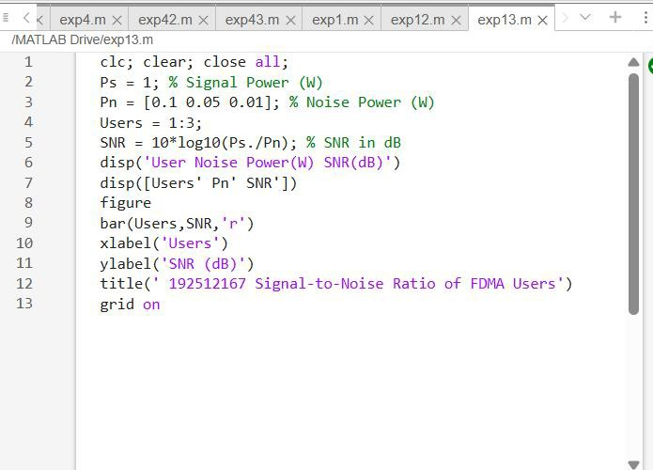

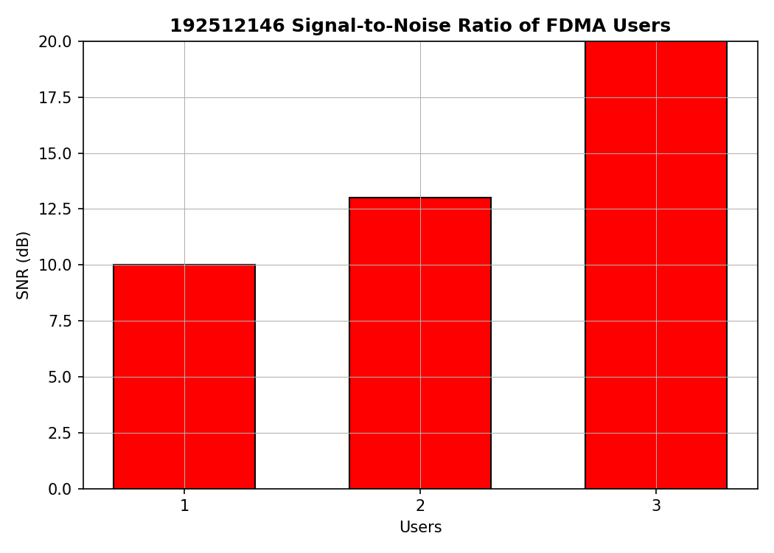

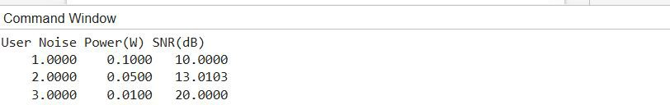

Result:

- The FDMA system was successfully simulated by allocating separate frequency channels
to three users, and the channel bandwidth assigned to each user was determined.
- The data rate achieved by each user was successfully calculated based on the allocated
channel bandwidth, demonstrating equal transmission capacity for all users.
- The Signal-to-Noise Ratio (SNR) for different users was successfully evaluated,
showing that higher SNR values provide better communication quality and reliable data
transmission.

